**Lab Exercise 4- Signed Commits in Git and GitHub**

**Objective:**

To configure Git to sign commits with GPG, push them to GitHub, and verify commit authenticity for secure code contribution.

**Prerequisites:**

* Git installed on your system
* GPG (GNU Privacy Guard) installed and configured
* GitHub account with a repository (you own or have write access to)
* Basic knowledge of Git commands

**Step 1 – Generate or Use an Existing GPG Key**

# Check for existing keys

gpg --list-secret-keys --keyid-format=long

# If no key exists, generate a new one

gpg --full-generate-key

# o Select RSA and RSA

* Key size: **4096**
* Expiration: **0** (never) or a fixed date

# o Enter your GitHub-registered name and email

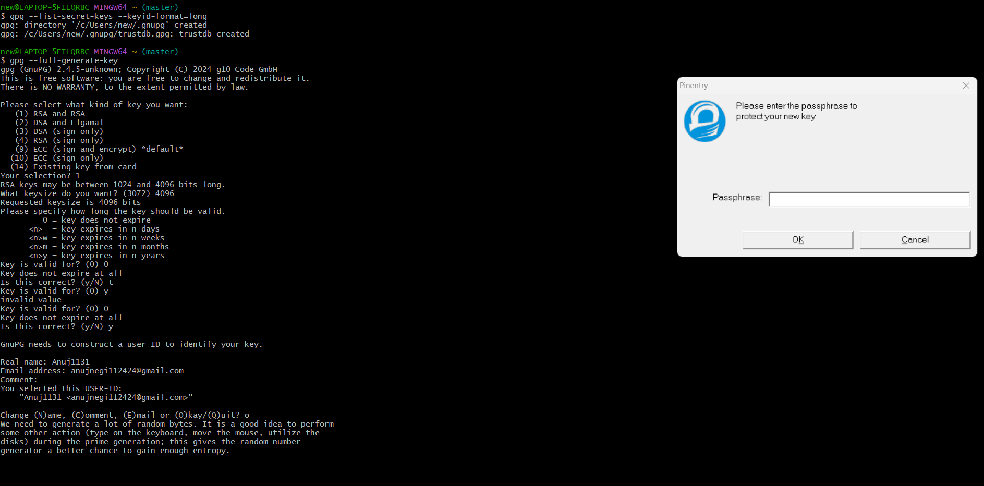

# Get your key ID

## gpg --list-secret-keys --keyid-format=long

Output:

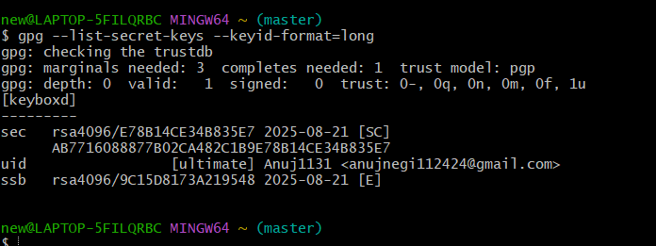

# Step 2 – Add GPG Key to GitHub

1. Export your public key:

## gpg --armor --export YOUR_KEY_ID

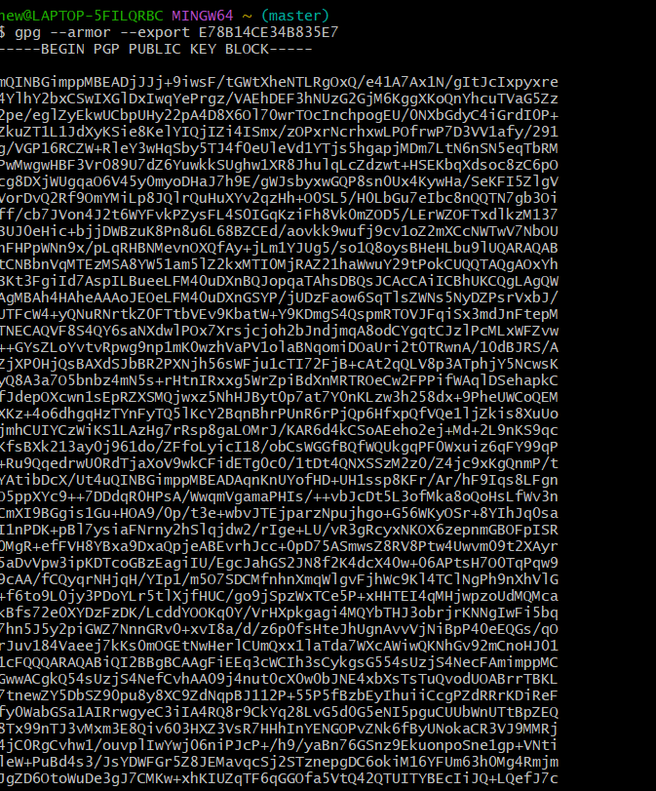

1. Copy the output.
2. Go to **GitHub → Settings → SSH and GPG Keys → New GPG Key**.
3. Paste your key and save.

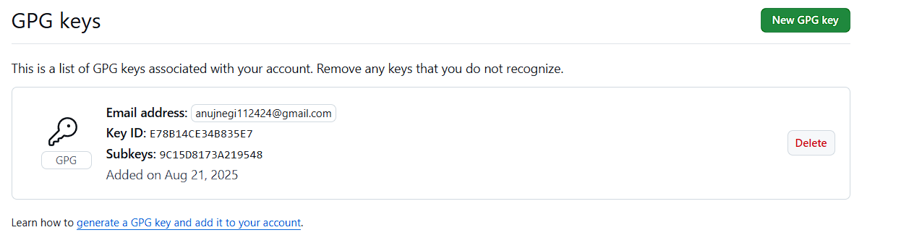

# Step 3 – Configure Git for Signed Commits

1. Tell Git which key to use:

git config --global user.signingkey YOUR_KEY_ID

1. Enable signing for all commits:

## git config --global commit.gpgsign true

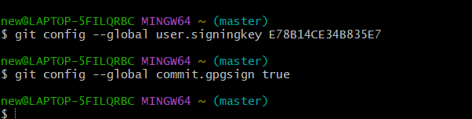

# Step 4 – Make a Signed Commit

1. Clone your repo (or use an existing one):

git clone https://github.com/<username>/<repository>.git

cd <repository>

1. Edit or create a file:

echo "Secure commit test" >> secure.txt

git add secure.txt

1. Commit with signing: 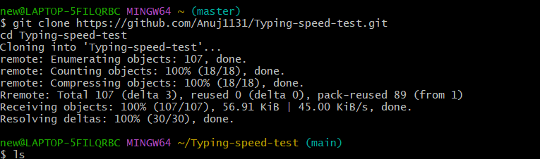

## 4. Enter your GPG passphrase when prompted.

# Step 5 – Push and Verify on GitHub

1. Push the commit: 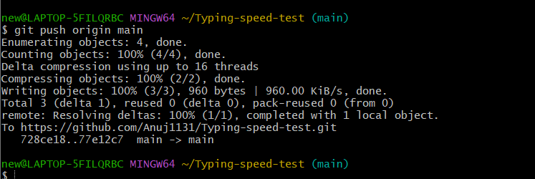

## git push origin main

2. Go to your repository on GitHub → Click the commit → You should see a **green “Verified” badge**. 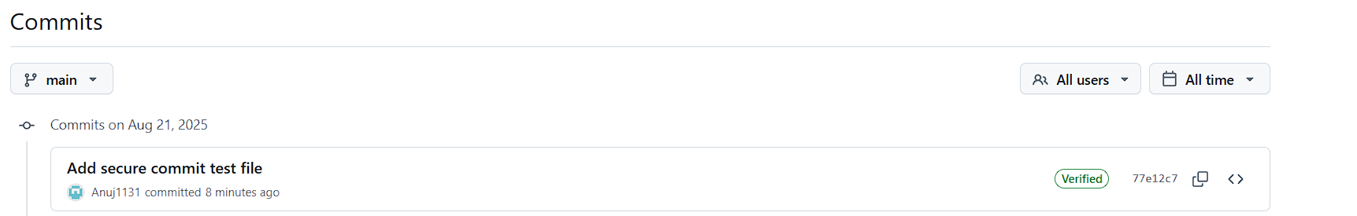

# Step 6 – Local Verification of Commit

## git log --show-signature

This will display the GPG verification details locally.

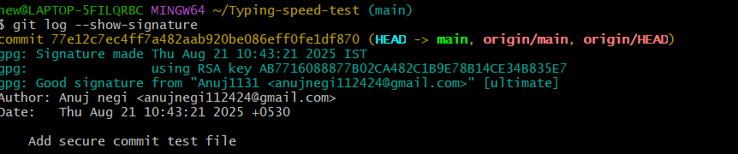

# Use Case

Signed commits prevent identity spoofing in collaborative projects, ensuring only verified authors can make trusted changes in critical codebases.